**Problem Number:** 2.29

**Student ID:** 1405048

**Event Graph:**

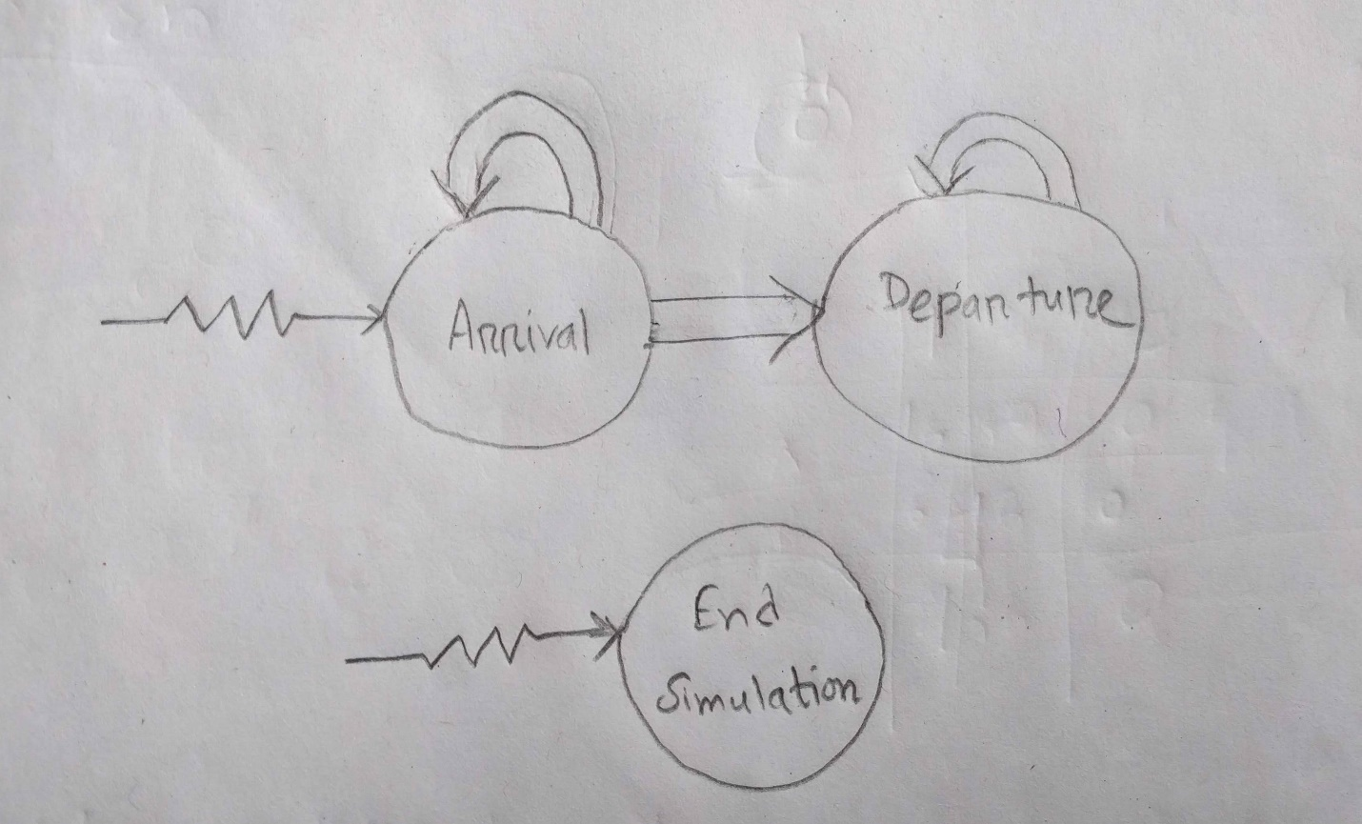

**Random Number Generators:**

* Stream 1: for determining the interarrival time of a customer
* Stream 2: for determining the service time of a customer
* Stream 3: for determining whether the service was satisfactory

**Performance Metrics:**

* Average and maximum total time in the system
* Number of satisfied customers who leave the system during the simulation
* Average and maximum length of the queue
* Time average and maximum number of servers that were busy

**Language /​Platform for Coding:** Python 3.6.5